Computer assignment - Linear Algebra

Jesper Wingren

Imported code is marked in blue

**Exercise 4.**

*4a)*

**A = [1 0;0 -1];**

**C = A * B;**

**plot(C(1, :), C(2, :), 'k.','MarkerSize', 1)**

**axis equal**

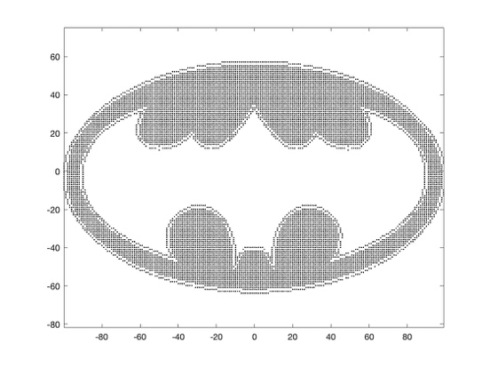

*4b)*

**theta = 120*pi/180;**

**rot = [cos(theta) -sin(theta);sin(theta) cos(theta)];**

**E = rot * B;**

**plot(E(1, :), E(2, :), 'k.','MarkerSize', 1)**

**axis equal**

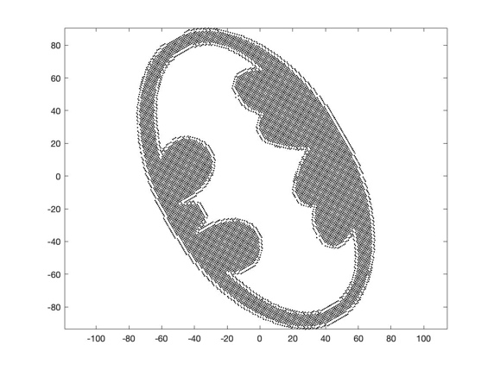

*4c)*

**stretch = [2 0;0 1];**

**G = stretch * B;**

**plot(G(1, :), G(2, :), 'k.','MarkerSize', 1)**

**axis equal**

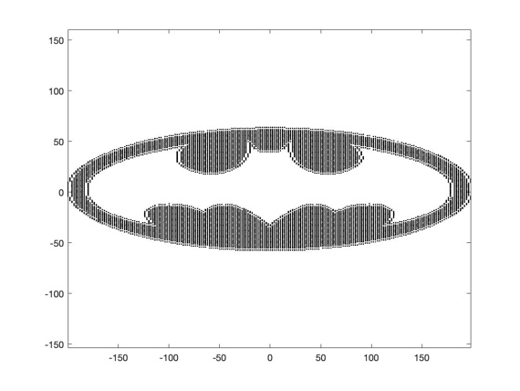

*4d)*

**theta = 60*pi/180;**

**rot = [cos(theta) -sin(theta);sin(theta) cos(theta)];**

**refl_y = [-1 0;0 1];**

**C = rot * B;**

**C = refl_y * C;**

**plot(C(1, :), C(2, :), 'k.','MarkerSize', 1)**

**axis equal**

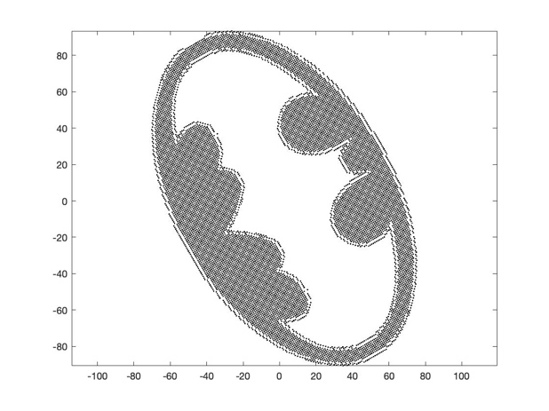

**Exercise 5.**

**rng(7)**

**n = 30;**

**center = [0 0];**

**radius = 1;**

**eps = 0.1;**

**r = eps * rand (n ,1) + radius - eps /2;**

**As = [center(1)+r.*cos(2*pi*(1: n )'/n) center(2)+r.*sin(2* pi *(1: n)'/n)];**

**b = As(:,1).^2 + As(:,2).^2;**

**plot(As(:,1), As(:,2), "b.");**

**hold on**

**A = As * 2;**

**A(:,3) = ones;**

**c = A\b;**

**radius = sqrt(c(3)+(c(1))^2+(c(2)^2));**

**th = 0:pi/100:2*pi;**

**xunit = radius * cos(th) + c(1);**

**yunit = radius * sin(th) + c(2);**

**plot(xunit,yunit);**

**hold off**

**axis equal**

**MSE = sum((radius^2-((As(:,1)-c(1)).^2) - ((As(:,2)-c(2)).^2)).^2)/30**

**5a)**

**Least squared solution:**

C = (0,0050, -0,0021, 1,0035)

**5b)**

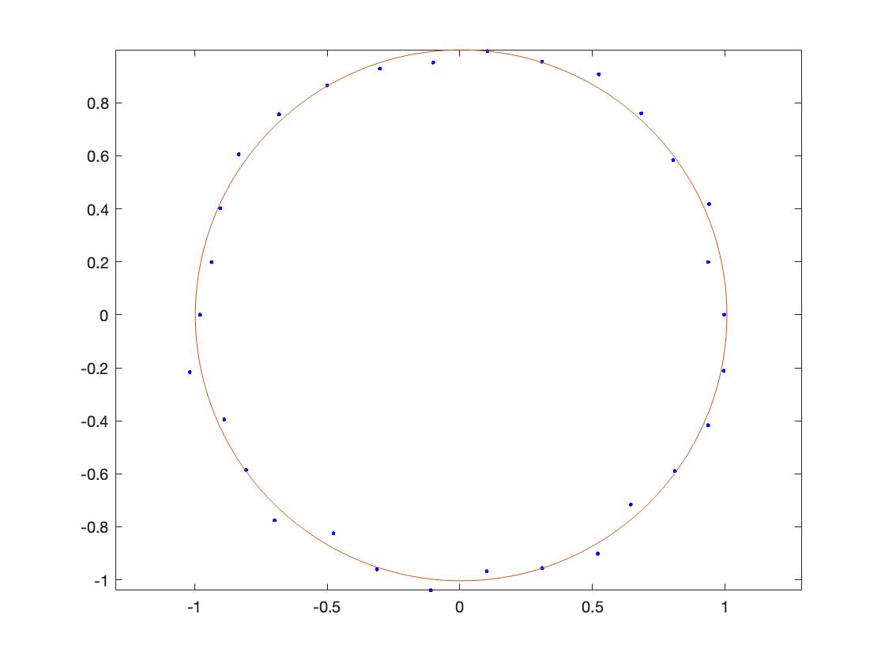

**5c)**

The MSE is 0,0033 and the most optimal answer is 0 because that would imply that the mean squared error being 0 thus its perfect on all points. But our solution gives us an 0,0033 mean squared error.

**Exercise 6.**

**x1 = 6;**

**y1 = 6;**

**z1 = (-x1 - y1)/6;**

**x2 = 6;**

**y2 = -6;**

**z2 = (-x2 - y2)/6;**

**x3 = -6;**

**y3 = -6;**

**z3 = (-x3 - y3)/6;**

**x4 = -6;**

**y4 = 6;**

**z4 = (-x4 - y4)/6;**

**plot3([0 u(1)],[0 u(2)],[0 u(3)], 'g', 'LineWidth', 2)**

**hold on**

**plot3([0 v(1)],[0 v(2)],[0 v(3)], 'r', 'LineWidth', 2)**

**plot3([0 w(1)],[0 w(2)],[0 w(3)], 'b', 'LineWidth', 2)**

**hold on**

**plot3([0 u(1)],[0 u(2)],[0 u(3)],'g-o', 'MarkerSize', 10)**

**plot3([0 v(1)],[0 v(2)],[0 v(3)],'r-s', 'MarkerSize', 10)**

**plot3([0 w(1)],[0 w(2)],[0 w(3)],'b-*', 'MarkerSize', 10)**

**hold on**

**x = [x1;x2;x3;x4];**

**y = [y1;y2;y3;y4];**

**z = [z1;z2;z3;z4];**

**fill3(x, y, z, 'b', 'facealpha', 0.4)**

**hold off**

**xlabel("x")**

**ylabel("y")**

**zlabel("z")**

**grid on**

**box on**

**set(gca,'fontsize',16)**

**axis equal**

**Figure from three different angles:**

